**Boarding House Finder: A Mobile Application for Safe and Verified Student Housing in Odiongan, Philippines**

A Capstone Project

Presented to the Faculty of the

Institute of Information Technology,

Romblon State University

In Partial Fulfillment of the Requirements

for the degree of Bachelor of Science in Information Technology

By

Roberto F. Cortez Jr.

BJ Stephen F. Falculan

Charles Lawrence L. Gregorio

Prexy Tupas

Adviser

October 2025

**Chapter I**

# Project Context

In recent years, boarding houses have become essential to Filipino higher education, accommodating the rising number of students who migrate from provinces to study in urban centers. Student housing plays a critical role in supporting academic performance, personal well-being, and parental peace of mind (Bustillo & Batistis, 2016). Parents often worry about the safety and health conditions of their children’s accommodations, while universities and local stakeholders also share responsibility in ensuring adequate living conditions (Metillo, 2023). Landlords and managers, on the other hand, are directly involved in providing spaces that meet student needs. Collectively, these stakeholders underscore the importance of secure and well-managed boarding houses in the Philippines.

However, local stakeholders face persistent challenges regarding the condition of many student boarding houses. Research highlights recurring issues such as inadequate sanitation, overcrowding, and unsafe facilities. For instance, Metillo (2023) reported that many boarding houses in Northern Samar failed to meet minimum health and safety standards, while Bustillo and Batistis (2016) documented similar deficiencies in Rizal, including poor ventilation and fire safety concerns. Likewise, Valderama and Villanueva (2013) noted the lack of systematic monitoring of student residences, which exposes students to risks that compromise both health and academic focus. These findings emphasize the urgent need to improve oversight and provide students with safer accommodation options.

Current systems are limited by their reliance on informal and fragmented methods for finding suitable housing. Word-of-mouth recommendations and generic online listings often lack transparency and verification, making it difficult for parents and students to assess living conditions accurately. While some local initiatives attempt to provide information, they are not centralized or consistently updated, leaving large gaps in reliability. Valderama and Villanueva (2013) stressed that universities alone cannot monitor all nearby accommodations, further exposing students to unregulated boarding houses. Thus, the absence of a student-centered, technology-supported platform continues to hinder safe and efficient housing access.

Aligned with the goals of student welfare and SDG 4 (Quality Education), this proposal introduces the Boarding House Finder, a mobile application designed to connect students with safe, verified, and suitable accommodations. This project positions itself as both a product development initiative and a public service. Beneficiaries include students, who gain access to verified housing; parents, who are assured of safety and suitability; university administrators, who can better safeguard student welfare; and reputable boarding house owners, who can attract tenants through verified listings. By addressing current gaps, the Boarding House Finder will strengthen the housing ecosystem that supports Filipino students’ educational journeys.

**Objectives of the Study**

**General Objective**

To design, develop, and evaluate a mobile application that provides safe, reliable, and verified boarding house options for students in Odiongan, Philippines.

**Specific Objectives**

1. To design a user-friendly mobile interface that allows students to search, filter, and view verified boarding houses based on location, budget, and amenities.
2. To develop and integrate a verification system for boarding house listings, ensuring authenticity and compliance with safety standards.
3. To implement geolocation and mapping features that provide real-time navigation to boarding houses.
4. To analyze user feedback from students and boarding house owners for system improvement.
5. To evaluate the application’s usability, accuracy, and effectiveness in addressing student housing challenges.

**Purpose and Description of the Study**

**Rationale**

Student housing is an important factor in academic success and well-being, yet many students struggle with unverified, unsafe, or misleading boarding house information (Brilliantes et al., 2012). In Odiongan, Romblon, the absence of a centralized and credible platform for locating secure and affordable accommodations poses risks to students’ safety and financial stability. Similar studies in other regions of the Philippines demonstrate the need for digital solutions that streamline the process of finding verified boarding houses (Nobis, 2022; Pernate et al., 2025). This project seeks to address these inefficiencies by leveraging mobile technology to provide reliable, accessible, and validated housing information.

**Project Description**

The proposed system, Boarding House Finder, is a mobile application designed to connect students with safe and verified boarding houses in Odiongan. The application will provide the following specific functions:

To enable students to search and filter boarding houses by price range, location, and amenities.

* To allow boarding house owners to upload verified property details with supporting documents.
* To implement a verification system where university administrators or trusted community representatives validate listings.
* To integrate Google Maps for navigation and proximity-based search results.
* To allow students to post reviews and ratings of boarding houses.

**Significance of the Study**

This study contributes to the body of knowledge by applying mobile application development to address the specific issue of student housing verification in a provincial setting. While previous works have introduced boarding house locator apps in other cities (Pernate et al., 2025; Esarakan, 2023), this project emphasizes the integration of a structured verification mechanism that enhances trust and safety. It also provides a model that can be replicated in other municipalities with similar housing challenges.

**Contribution to Specific Beneficiaries**

* **University Administrators**

The application provides administrators with insights into the living conditions of students, ensuring welfare monitoring and enabling them to recommend verified housing options.

* **Students**

Students gain access to a reliable platform where they can compare options, check verified listings, and make safer and more informed decisions about where to live. This minimizes risks of financial exploitation and unsafe accommodations.

* **Local Community of Odiongan, Romblon**

By promoting legitimate and verified boarding houses, the system helps build community trust and supports local economic activity, benefiting responsible boarding house operators.

* **Boarding House Owners**

Verified landlords gain a competitive advantage through digital visibility, improved tenant trust, and increased occupancy rates.

* **Future Researchers**

The project serves as a foundation for future academic studies in mobile housing platforms, safety verification systems, and location-based service applications in rural or semi-urban settings.

## Scope and Limitations

This study focuses on the design, development, and implementation of a mobile application called "Boarding House Finder" aimed at providing safe and verified student housing options specifically in Odiongan, Romblon, Philippines. The application targets students attending local educational institutions, offering features such as verified boarding house listings, user reviews, geolocation mapping, and a reporting system for university administrators.

The scope of the project includes:

* Providing a centralized platform for students to search for boarding houses within Odiongan.
* Ensuring the safety and authenticity of boarding house listings through a verification process conducted by university administrators and trusted local representatives.
* Facilitating communication and feedback through user ratings and reviews to improve housing quality.
* Assisting university officials in monitoring and managing student housing options.

However, the study has certain limitations:

* The application is geographically limited to Odiongan and does not cover boarding houses outside this area.
* The verification process relies on university administrators, which may affect the speed and coverage of verification.
* The effectiveness of the system depends on users having access to mobile devices and a stable internet connection.
* The application’s data is limited to information voluntarily provided by boarding house owners and users, which may affect completeness and accuracy.

This study does not cover other forms of student accommodation such as dormitories or family homes, nor does it address long-term rental agreements outside the student housing context.

|  |  |
| --- | --- |
|  |  |
|  |  |

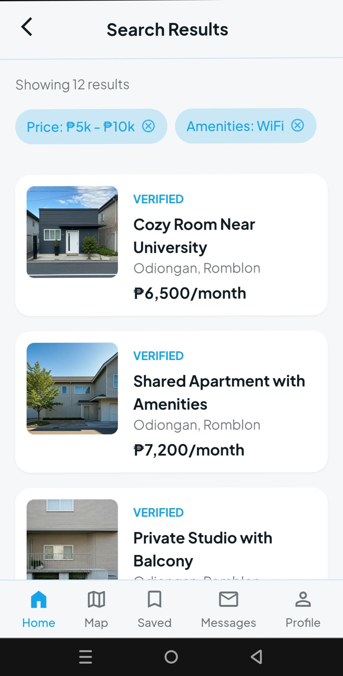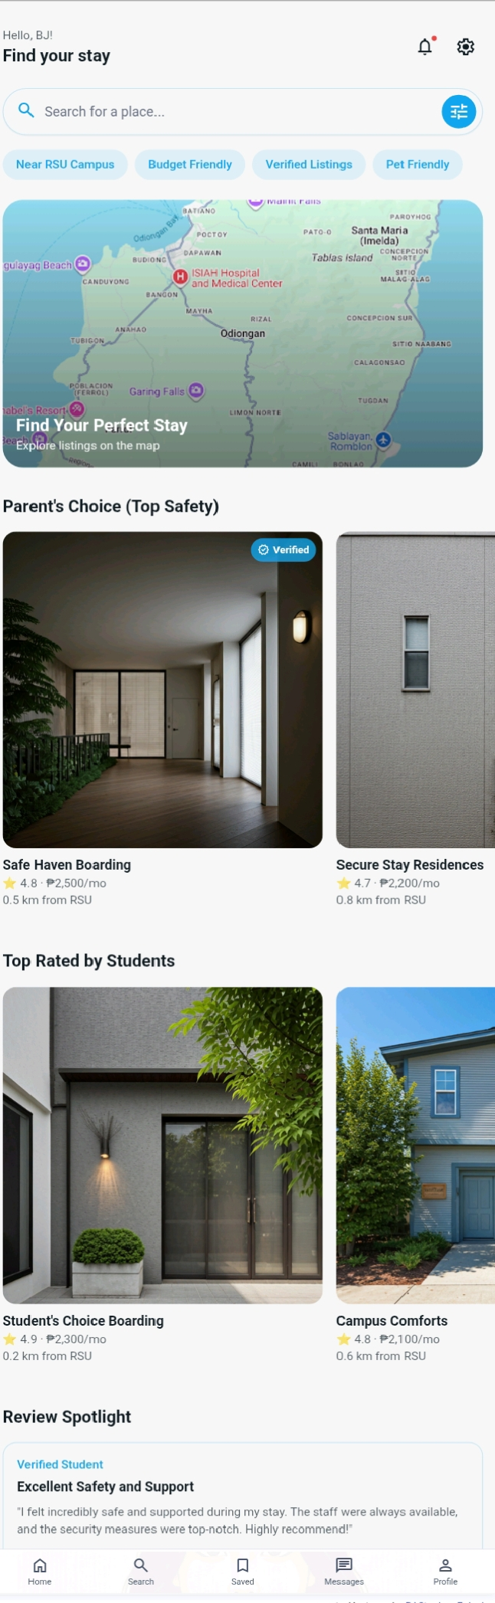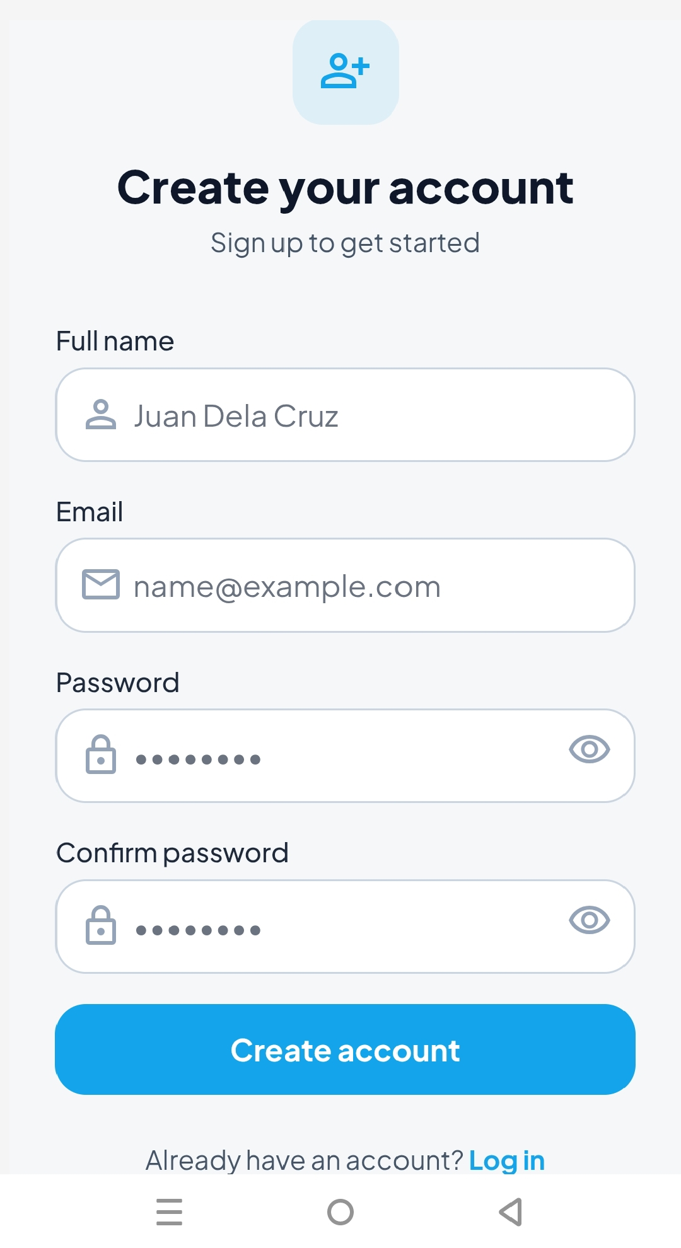

**References**

Nobis, M. (2022). Status of students’ boarding houses in the University of Eastern Philippines, Laoang Campus. Retrieved from https://www.researchgate.net/publication/367241563_Status_of_Students'_Boarding_Houses_in_the_University_of_Eastern_Philippines_Laoang_Campus

Pernate, W., Rosales, D., Aya-ay, L., & Artigas, A. (2025). BH Niyo App: A smart mobile solution for boarding house room rentals in Ormoc City. Retrieved from https://www.researchgate.net/publication/382409195_Mobile_Web-Based_Information_System_As_Information_For_Searching_For_Boarding_Houses_For_Students

Libre, R. (2012). iBoarding House Locator and Student Monitoring System. Retrieved from https://d1wqtxts1xzle7.cloudfront.net/48086698/52-libre.pdf

Metillo, C. A. (2023). *Status of students’ boarding houses in the University of Eastern Philippines, Laoang Campus*. [https://www.academia.edu/download/108032761/41.pdf](<https://www.academia.edu/download/108032761/41.pdf>)

Bustillo, R. G., & Batistis, B. G. (2016). *Boarding house locator and student monitoring system in Naval, Biliran Province, Philippines*. *International Journal of Engineering Sciences & Research Technology, 5*(8), 468–480. [https://doi.org/10.5281/zenodo.60089](<https://doi.org/10.5281/zenodo.60089>)

Valderama, J. S., & Villanueva, J. M. (2013). *Conditions of the nearby boarding houses of a state university in the Northern Philippines: A benchmark study*. *IAMURE International Journal of Business and Management, 5*(1). [https://ejournals.ph/article.php?id=3628](<https://ejournals.ph/article.php?id=3628>)

Brilliantes, R. A., Aga, N. B., Adegue, C. I., Perez, M. P., Aya-ay, A. M., & Sagarino, E. V. (2012). *The living conditions of university students in boarding houses and dormitories in Davao City, Philippines*. *IAMURE International Journal of Social Sciences, 1*(1). [https://ejournals.ph/article.php?id=565](<https://ejournals.ph/article.php?id=565>)